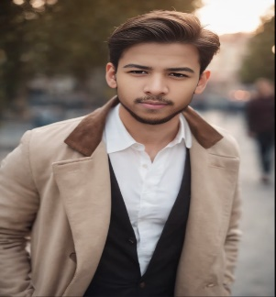 Abdul Samad

Frontend Developer

|  |
| --- |
| About Me  Name : Abdul Samad  Age : 16  DOB : 31-12-2008  Post : Frontend Developer  Language : Urdu  Speaker phone with solid fill 03329183482  Marker with solid fill Karachi , Pakistan  Email with solid fill samadtalhaff@gmail.com@gmail.com |

**Language**

* ENGLISH
* Arabi
* URDU